**Project 1**

**<Tic Tac Toe>**

**CSC 5 - 40108**

**Ghislain Muberwa**

**Date: 01/29/2017**

**Introduction**

Title: Tic Tac Toe

This is a simple game called tic tac toe. It is played with two players on a 3 x 3 board where one player marks ‘X’ and the other player ‘O’ on the board and the purpose is to match three of the same mark in a line in any direction possible. If there is no winner, the game ends in a tie.

**Summary**

Project size: about 200 lines

The numbers of variables: 29

The number of methods: 1

Everything is placed in the main() method. The whole game, Tic Tac Toe, is placed in a do-while loop where in the end, the player chooses to play the game again.

Each square is a char variable where it starts as a number and are slowly being replaced by either an ‘X’ or ‘O’.

All inputs are verified to be correct or not.

There is a possibility of either one of the player or neither to win.

After answering no to continue to play the game, there is an output of all the wins and ties of all the matches between the two players, a percentage of the win and tie.

The results from the win and tie is saved into a file and then it is printed again to confirm that the content is in the file the way it is was originally.

**Description**

The program is a Tic Tac Toe game that draws a board and update the output based on user input. The game goes until a winner connects three of their mark in a line or no winner is selected. There is also the option of playing again until they do not want to.

**Flowchart**

Part 1

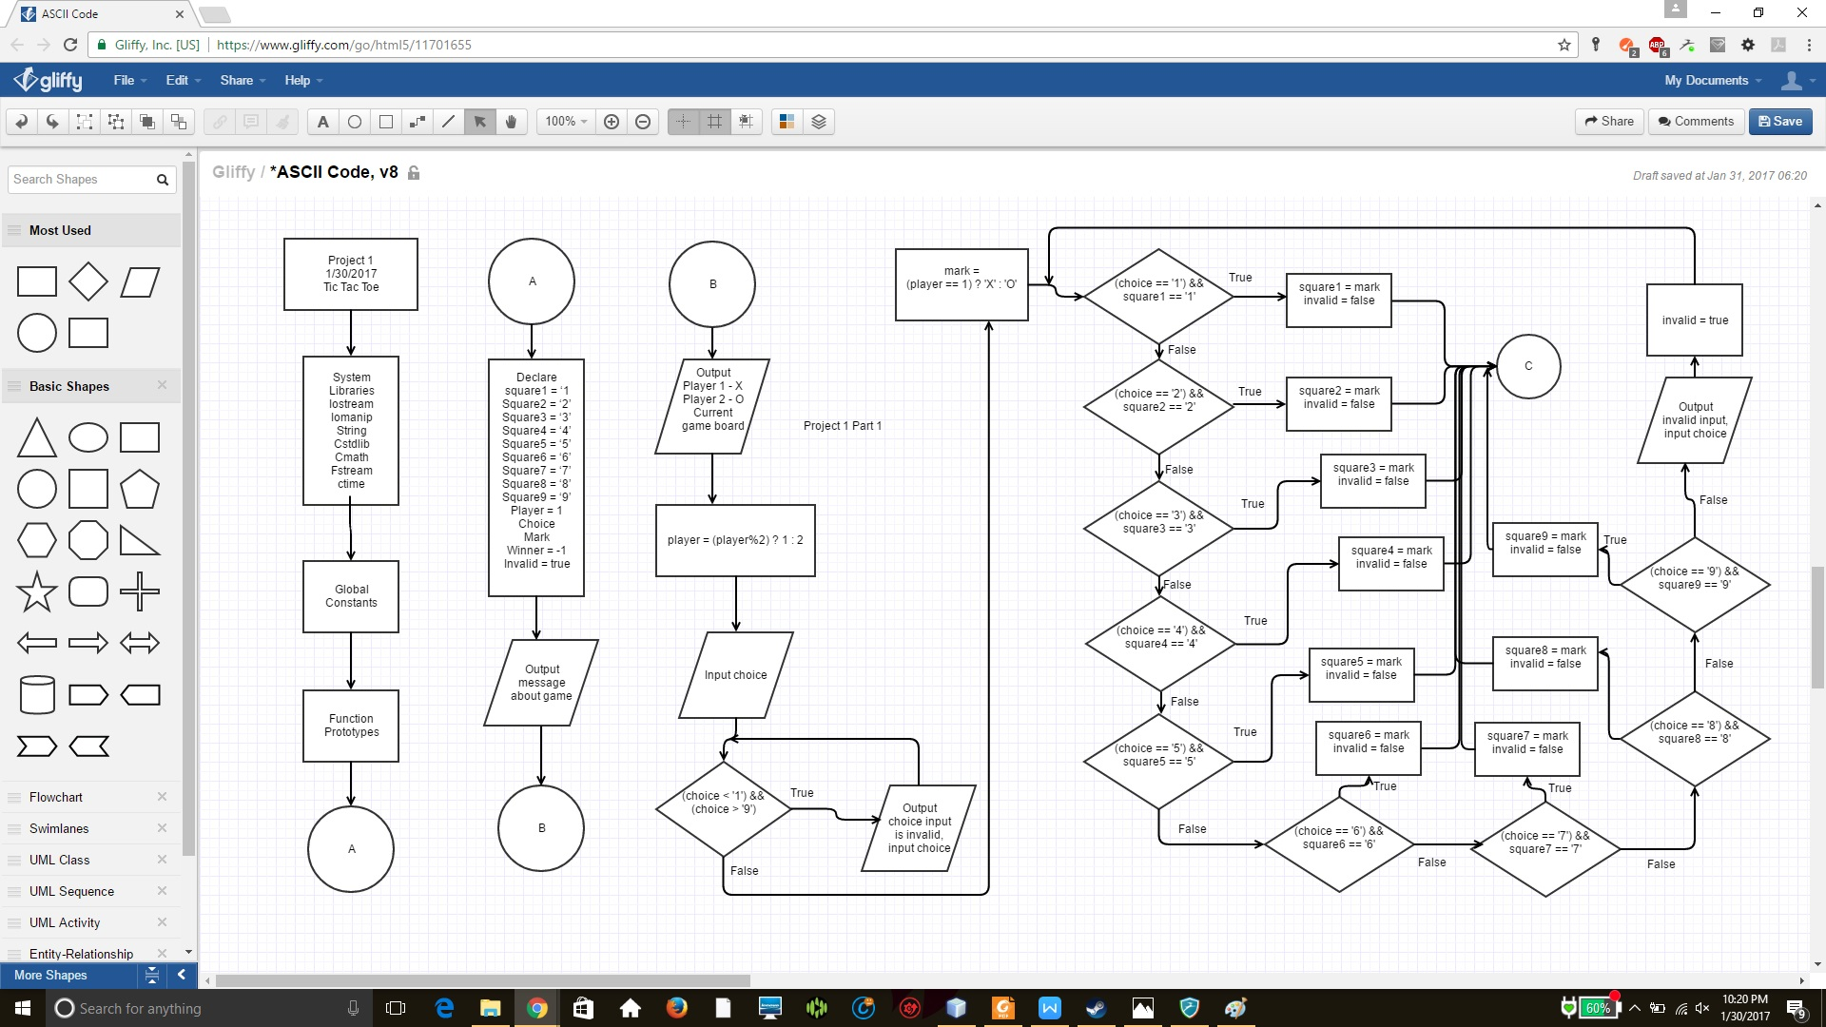

Part 2

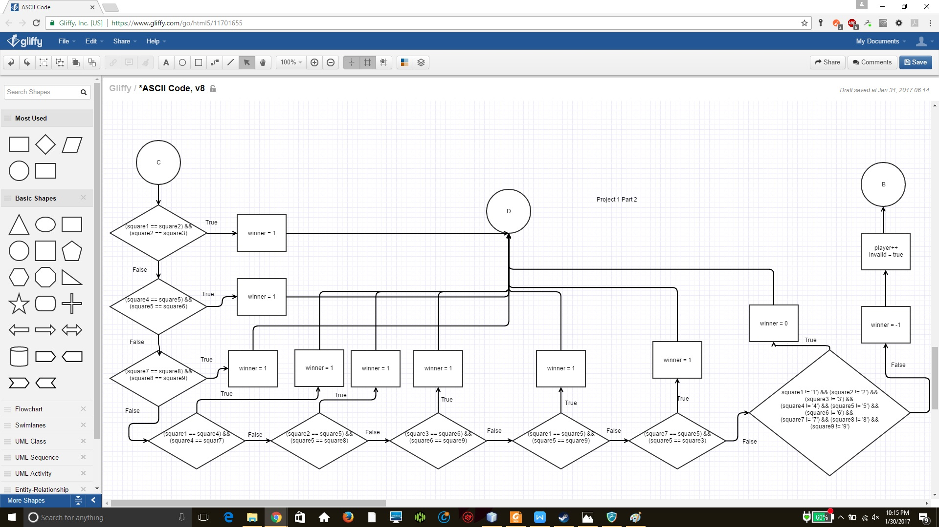

Part 3

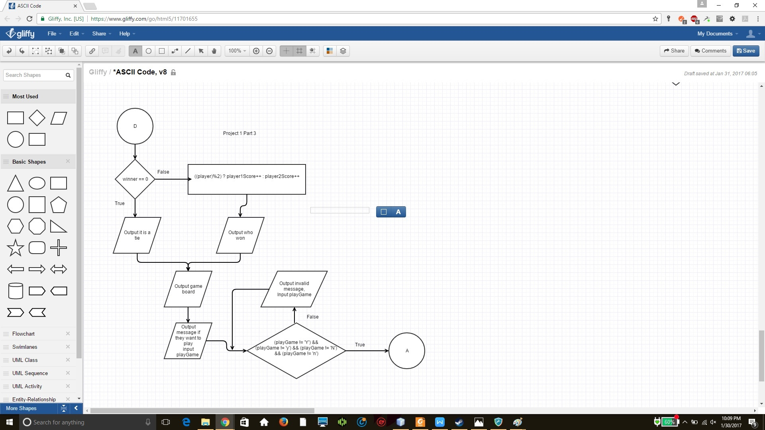

**Pseudo-code**

Initialize board

Player enters a number

Check if input is valid

Check if any player won or tie game

If someone won or tie game exit to show who one

Else next player’s turn

Show result of game

Ask if player wants to play again

If yes return to initialize board

If no go to save result to file

Save result to file

Output content form file to con

**Major variable**

|  |  |  |  |
| --- | --- | --- | --- |
| **Type** | **Variable Name** | **Description** | **Location** |
| Float | totalGames | Hold total amount of games played | Main() |
| Char | playGame | Hold answer as to if player wants to play again |  |
|  | Square1 | Display top left content |  |
|  | Square2 | Display top middle content |  |
|  | square3 | Display top right content |  |
|  | Square4 | Display middle left content |  |
|  | Square5 | Display center content |  |
|  | Square6 | Display middle right content |  |
|  | Square7 | Display bottom left content |  |
|  | Square8 | Display bottom middle content |  |
|  | Square9 | Display bottom right content |  |
|  | Choice | Holds which player the user chooses |  |
|  | Mark | Replaces the selected square with either X or O |  |
| integer | Player1Score | Hold player 1 score |  |
|  | Player2Score | Hold player 1 score |  |
|  | tieGame | Identify how many tie games occurred |  |
|  | Player | Used to identity player 1 or player 2 |  |
|  | Winner | Identify if a player one or a tie game |  |
| Boolean | Invalid | Check if player’s move was valid |  |

**C++ Construct**

|  |  |  |
| --- | --- | --- |
| Chapter | New syntax and keyword | Location |
| 2 | Cout | Main() |
|  | Libraries (Iostream, iomanip, fstream, string) |  |
|  | Variables/literals |  |
|  | Integer |  |
|  | Character |  |
|  | Float |  |
|  | Bool |  |
|  | Variables 7 letters or less |  |
|  | Arithmetic operators |  |
|  | Comments 20%+ |  |
|  | Named constants |  |
| 3 | Cin |  |
|  | Math expression |  |
|  | Type casting |  |
|  | Formating output |  |
| 4 | Relational operators |  |
|  | If |  |
|  | If-else |  |
|  | Nesting |  |
|  | Logical operators |  |
|  | Validate user input |  |
|  | Conditional operator |  |
| 5 | Increment |  |
|  | While |  |
|  | Do-while |  |
|  | File input/output both |  |

/*File: main.cpp

Author: Ghislain Muberwa

Created on January 29, 2017, 4:04 PM

Purpose: Implement a two player Tic Tac Toe game

*/

//System Libraries

#include <iostream>

#include <iomanip>

#include <string> //String class

#include <cstdlib> //Timer class

#include <cmath> //Math class

#include <fstream>

#include <ctime>

using namespace std;

//User Libraries

//Global Constants

//Such as PI, Vc, -> Math/Science values

//as well as conversions from system of units to

//another

//Function Prototypes

//Executable code begins here!!!

int main(int argc, char** argv) {

//Declare Variables

//Holds how many wins each player won

int player1Score = 0; //Holds how many games player 1 won

int player2Score = 0; //Holds how many games player 2 won

int tieGame = 0; //Holds tie games

float totalGames; //How many games were played

char playGame; //Hold response of if player wants to play again

cout << setprecision(1) << showpoint << fixed;

do{

//Initialize board

char square1 = '1'; //Start of first row

char square2 = '2';

char square3 = '3';

char square4 = '4'; //Start of second row

char square5 = '5';

char square6 = '6';

char square7 = '7'; //Start of third row

char square8 = '8';

char square9 = '9';

int player = 1; //indicate player's turn

char choice; //Hold user's choice

char mark; //Change square to either X or O

int winner = -1; //Verify who the winner is

bool invalid = true; //Check that move was valid

//Message to tell what the game is

cout << "Welcome to Tic Tac Toe. This is a two player game where "

<< "each player will try to match either three X or O in a line. Player “

<< “1 will be X and Player 2 will be O.\n\n";

do{

cout << "Player 1 = X Player 2 = O" << endl;

//Draw current game board

cout << " | | " << endl;

cout << " " << square1 << " | " << square2 << " | " << square3 << endl;

cout << "_______|_______|_______" << endl;

cout << " | | " << endl;

cout << " " << square4 << " | " << square5 << " | " << square6 << endl;

cout << "_______|_______|_______" << endl;

cout << " | | " << endl;

cout << " " << square7 << " | " << square8 << " | " << square9 << endl;

player = (player%2) ? 1 : 2; //Identity current player

cout << "Current player: " << player << " enter a number: ";

cin >> choice; //Obtain player's choice;

//Check if input is appropriate

while((choice < '1') && (choice > '9')){

cout << "Please enter a number between 1 and 9: ";

cin >> choice;

}

mark = (player == 1) ? 'X' : 'O'; //Use appropriate mark for player

//Find which square was selected and replace it with appropriate mark

while(invalid){ //Stay in same turn until valid choice is implemented

if((choice == '1') && square1 == '1'){

square1 = mark;

invalid = false;

}

else if((choice == '2') && square2 == '2'){

square2 = mark;

invalid = false;

}

else if((choice == '3') && square3 == '3'){

square3 = mark;

invalid = false;

}

else if((choice == '4') && square4 == '4'){

square4 = mark;

invalid = false;

}

else if((choice == '5') && square5 == '5'){

square5 = mark;

invalid = false;

}

else if((choice == '6') && square6 == '6'){

square6 = mark;

invalid = false;

}

else if((choice == '7') && square7 == '7'){

square7 = mark;

invalid = false;

}

else if((choice == '8') && square8 == '8'){

square8 = mark;

invalid = false;

}

else if((choice == '9') && square9 == '9'){

square9 = mark;

invalid = false;

}

else{

cout << "Invalid move please try again: ";

cin >> choice;

invalid = true;

}

}

//Check if there is a winner

if((square1 == square2) && (square2 == square3)) //First row match

winner = 1;

else if((square4 == square5) && (square5 == square6)) //Second row match

winner = 1;

else if((square7 == square8) && (square8 == square9)) //Third row match

winner = 1;

else if((square1 == square4) && (square4 == square7)) //First column match

winner = 1;

else if((square2 == square5) && (square5 == square8)) //Second column match

winner = 1;

else if((square3 == square6) && (square6 == square9)) //Third column match

winner = 1;

else if((square1 == square5) && (square5 == square9)) //Diagonal down match

winner = 1;

else if((square7 == square5) && (square5 == square3)) //Diagonal up match

winner = 1;

else if((square1 != '1') && (square2 != '2') && (square3 != '3') &&

(square4 != '4') && (square5 != '5') && (square6 != '6') &&

(square7 != '7') && (square8 != '8') && (square9 != '9'))

winner = 0;

else{

winner = -1;

player++; //Increment player variable to allow next player to play

invalid = true;

}

}while(winner == -1);

//Output who won

cout << endl;

if(winner == 0){

cout << "Game is a tie" << endl;

}

else{

((player)%2) ? player1Score++ : player2Score++;

cout << "The winner is Player " << ((player)%2 ? 1 : 2) << ", this is the winning board" << endl;

}

//Draw winning game board

cout << " | | " << endl;

cout << " " << square1 << " | " << square2 << " | " << square3 << endl;

cout << "_______|_______|_______" << endl;

cout << " | | " << endl;

cout << " " << square4 << " | " << square5 << " | " << square6 << endl;

cout << "_______|_______|_______" << endl;

cout << " | | " << endl;

cout << " " << square7 << " | " << square8 << " | " << square9 << endl;

cout << endl;

//Ask if player wants to play again

cout << "Do you want to play again (Y for yes, N for no): ";

cin >> playGame;

while((playGame != 'Y') && (playGame != 'y') && (playGame != 'N') &&

(playGame != 'n')){

cout << "Please enter Y for yes or N for no: ";

cout << playGame;

}

}while((playGame == 'Y') || (playGame == 'y'));

//Output results of all games

totalGames = player1Score + player2Score + tieGame;

cout << "at the end of all the games, this is the final score:\n";

cout << "Player 1: " << player1Score << " Winning ratio: " << ((player1Score/(float)totalGames)*100) << "%" << endl;

cout << "Player 2: " << player2Score << " Winning ratio: " << ((player2Score/(float)totalGames)*100) << "%" << endl;

cout << "Tie game: " << tieGame << " tie ratio: " << (tieGame/(double)totalGames) << "%" << endl;

cout << endl;

//Save final game

ofstream outputFile;

outputFile.open("saveGame.txt");

cout << "Saving scores..." << endl;

outputFile << "Player 1: " << player1Score << " Winning ratio: "

<< ((player1Score/(float)totalGames)*100) << "%\n";

outputFile << "Player 2: " << player2Score << " Winning ratio: "

<< ((player2Score/(float)totalGames)*100) << "%\n";

outputFile << "Tie game: " << tieGame << " tie ratio: " << (tieGame/(double)totalGames)

<< "%\n";

cout << "Done.\n\n";

//Close file

outputFile.close();

//Reading file

string player1Results;

string player2Results;

string tieGameResults;

ifstream inputFile;

inputFile.open("saveGame.txt");

//Output file content

cout << "Result from previous games:\n";

getline(inputFile, player1Results);

cout << player1Results << endl;

getline(inputFile, player2Results);

cout << player2Results << endl;

getline(inputFile, tieGameResults);

cout << tieGameResults << endl;

//Close file

inputFile.close();

//Exit stage right!

return 0;

}